**----------------------------------------------------**

NAME  **:** Atharv Santosh Ghule

BRANCH **:** FYBsc.IT

DIV  **:** A

ROLL NO  **:** 1904

SUBJECT  **:** C Programming.

**----------------------------------------------------**

C PROGRAMS

* Program:1

**INPUT:**

*//PROGRAM FOR HELLO WORLD   1904*

#include <stdio.h>

int main()

{

printf("HELLO WORLD");

return 0;

}

**OUTPUT :**

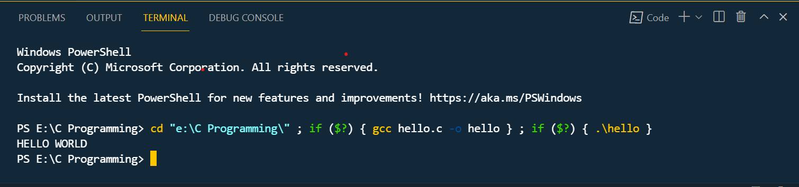

* Program:2

**INPUT:**

*//PROGRAM FOR ADD,SUB,MUL,DIV 1904*

#include <stdio.h>

int main()

{

    int a,b,res;

    printf("enter two numbers");

scanf("%d%d",&a,&b);

res =a*b;

printf("\nThe Addition is %d",a+b);

printf("\tThe Subtraction is %d",a-b);

printf("\nThe Multiplication is %d",a*b);

printf("\tThe Division is %d",a/b);

return 0;

**OUTPUT:**  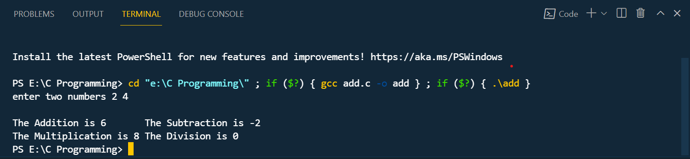

* Program:3

**INPUT:**

*//PROGRAM FOR AREA OF CIRCLE,REACTANGLE,SQUARE 1904*

#include <stdio.h>

int main()

{

float rad,areac,areasq,length,breadth,side,pi=3.14;

printf("Enter the Radius of circle");

scanf("%f",&rad);

areac= pi*rad*rad;

printf("Area of Circle= %f",areac);

printf("\n Enter values for length and breadth of rectangle:");

scanf("%f%f",&length,&breadth);

printf("\nArea of Rectangle is:%f",length*breadth);

printf("\nEnter value for side of Square");

scanf("%f",&side);

areasq=side*side;

printf("\nArea of Square is :%f",areasq);

return 0;

}

**OUTPUT:**

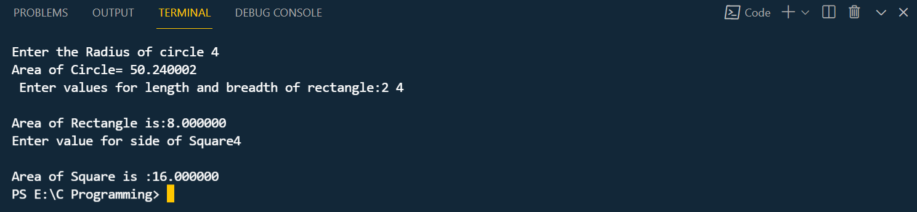

* Program:4

**INPUT:**

*//PROGRAM FOR SWAPPING OF TWO NUMBERS  1904*

#include <stdio.h>

int main()

{

    int num1,num2;

    printf("Enter two numbers");

    scanf("%d%d",&num1,&num2); //num=24 num2=10

    printf("The numbers are:%d  %d",num1,num2);

    num1=num1+num2; //num1=34

    num2=num1-num2; //num2=24

    num1=num1-num2; //num1=10

    printf("\nThe swapped values are: %d %d",num1,num2);

    return 0;

}

**OUTPUT:**

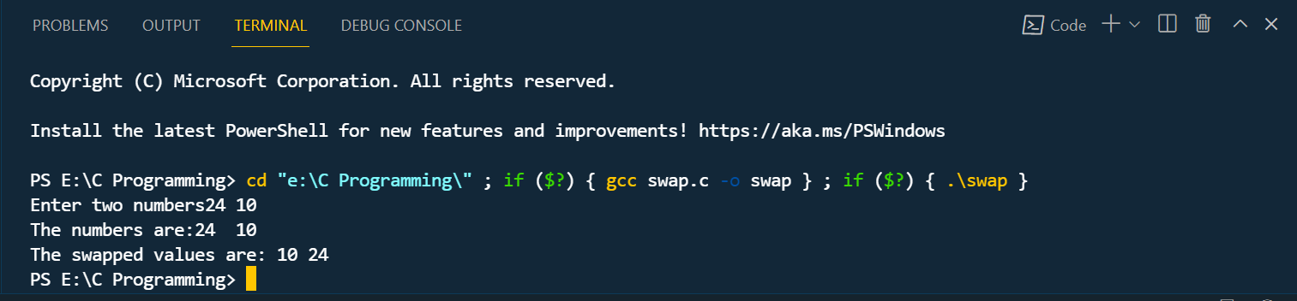

* Program:5

**INPUT:**

*//DECLARING THE VARIABLES OF INT, FLOAT   1904*

#include <stdio.h>

int main()

{

    int a=4;

    char b='v';

    float c=3.1;

    printf ("The values are: \n%d,\n%c,\n%f",a,b,c);

    return 0;

}

**OUTPUT:**

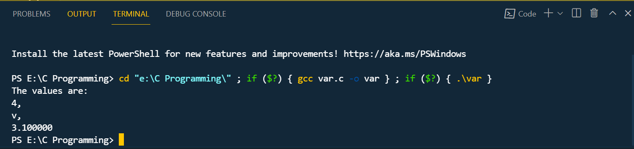

* Program:6

**INPUT:**

*//PROGRAM FOR VOTING ELIGIBLITY  1904*

#include <stdio.h>

int main()

{

int age;

printf("Enter your age:");

scanf("%d",&age);

if(age>=18)

{

printf("Eligible To Vote");

}

else

{

printf("Not Elgible To Vote");

}

return 0;

}

**OUTPUT:** 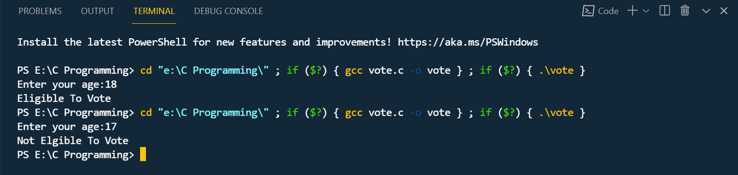

* Program:7

**INPUT:**

*// PROGRAM TO CHECK WHETHER THE NO.IS EVEN OR*

*ODD  1904*

#include <stdio.h>

int main()

{

    int num;

    printf("Enter a number");

    scanf("%d",&num);

    if(num%2==0)

    {

        printf("number is even");

    }

    else

    {

        printf("number is odd");

    }

    return 0;

}

**OUTPUT:**

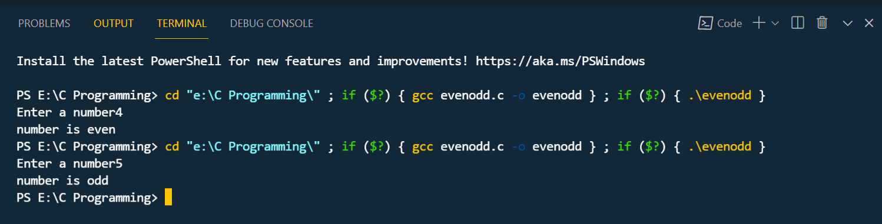

* Program:8

**INPUT:**

*//PROGRAM FOR ELIGIBLITY FOR MARRIAGE   1904*

#include <stdio.h>

int main ()

{

    char gen;

    int age;

    printf("Enter your Gender");

    scanf("%c",&gen);

    printf("Enter your Age");

    scanf("%d",&age);

    if(gen=='M')

    {

        if(age>=21)

        {

        printf("Eligible for Marriage""\n");

    }

    else

    {

        printf("MALE NOT ELIGIBLE FOR MARRIAGE""\n");

    }

 }

    else

    {

    if(gen=='F')

    {

        if(age>=18)

        {

        printf("Eligible for Marriage""\n");

        }

        else

        {

        printf("FEMALE NOT ELIGIBLE FOR MARRIAGE""\n");

    }

    }

    }

    return 0;

    }

**OUTPUT:**

*( FOR MALE GENDER )*

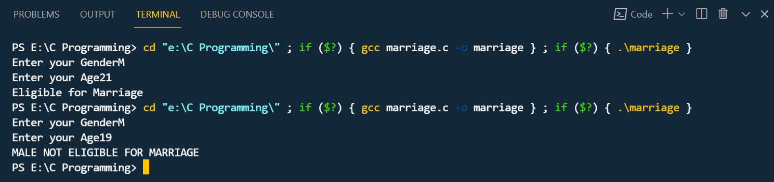

*( FOR FEMALE GENDER)*

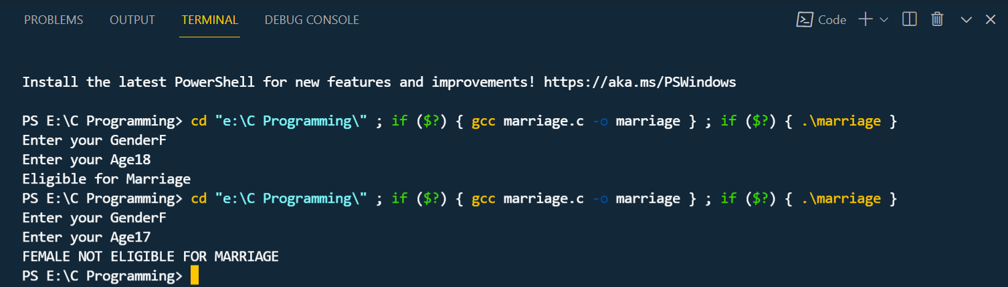

* Program:9

**INPUT:**

*//PROGRAM FOR DECLARING LENGTH OF ARRAY  1904*

#include <stdio.h>

#include<string.h>

int main()

{

    char name[10];

    int len;

    printf("Enter Your Name:");

    for (int i=0;i<10;i++)

    scanf("%c",&name[i]);

    len=strlen(name);

    printf("\n""The length of array name is:%d,len");

    for(int i=0;i<10;i++)

    printf("\n%c",name[i]);

    return 0;

}

**OUTPUT:**

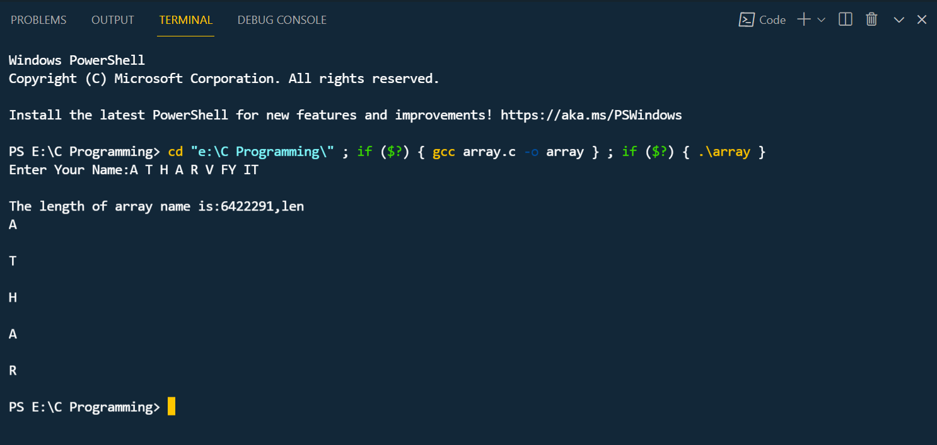

* Program:10

**INPUT:**

*//PROGRAM FOR ENTERING NUM FROM USER & DISPLAY MONTH NAME (SWITCH CASE)  1904*

#include<stdio.h>

#include<conio.h>

void main()

{

int i;

printf("Enter the number:");

scanf("%d",&i);

switch(i)

{

case 1:

printf("JANUARY");

break;

case 2:

printf("FEBRUARY");

break;

case 3:

printf("MARCH");

break;

case 4:

printf("APRIL");

break;

case 5:

printf("MAY");

break;

case 6:

printf("JUNE");

break;

case 7:

printf("JULY");

break;

case 8:

printf("AUGUST");

break;

case 9:

printf("SEPTEMBER");

break;

case 10:

printf("OCTOBER");

break;

case 11:

printf("NOVEMBER");

break;

case 12:

printf("DECEMBER");

break;

default:

printf("INVALID INPUT");

}

getch();

}

**OUTPUT:**

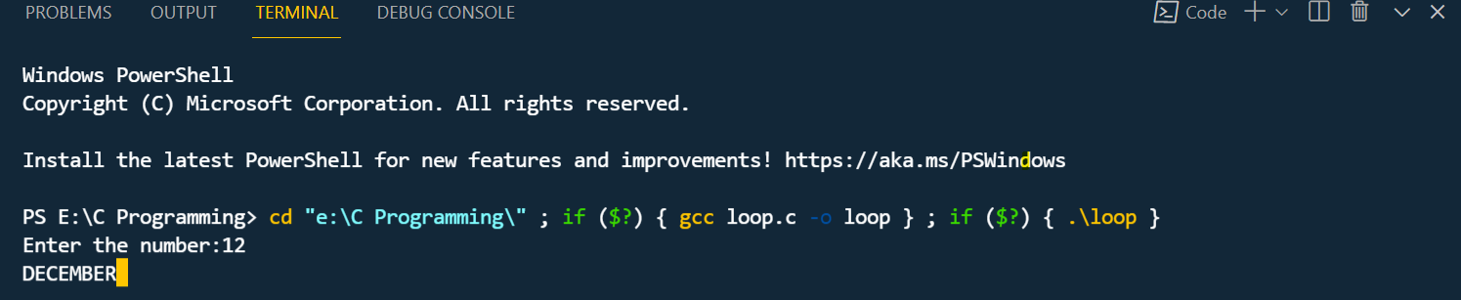

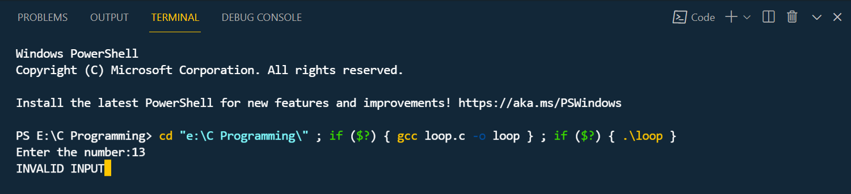

* Program:10

**INPUT:**

*//PROGRAM FOR FACTORIAL  1904*

#include <stdio.h>

long int multiplyNumbers(int n);

void main()

{

    int n;

    printf("Enter a postive integer:");

    scanf("%d", &n);

    printf("Factorial of%d = %ld", n,multiplyNumbers(n));

}

long int multiplyNumbers(int n)

{

    if(n >=1)

    return n*multiplyNumbers(n-1);

    else

    return 1;

}

**OUTPUT:**

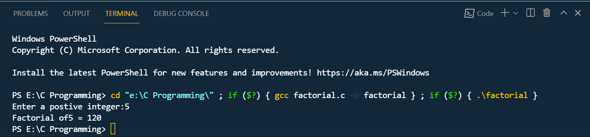

* Program:11

**INPUT:**

*//PROGRAM FOR SUM  1904*

#include<stdio.h>

int main ()

{

    int number,result;

    printf("Enter a postive number:");

    scanf("%d",&number);

    result=sum(number);

    printf("sum=%d",result);

    return 0;

}

int sum(int n)

{

    if(n!=0)

    return n+sum(n-1);

    else

    return n+1;

}

**OUTPUT:**

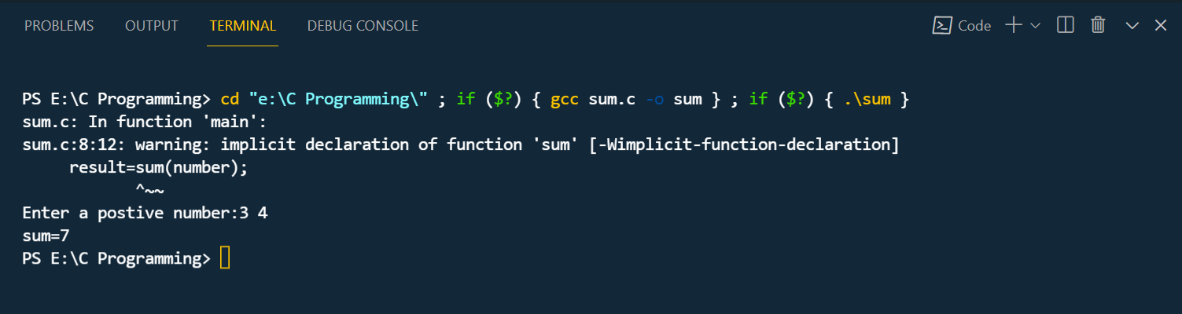

* Program:12

**INPUT:**

*//PROGRAM FOR A PATTERN  1904*

#include <stdio.h>

#include <conio.h>

int main()

{

    int i,j;

    for(i=1;i<=5;i++)

    {

    for(j=1;j<=i;j++)

    {

    printf("#");

    }

    printf("\n");

    }

    return 0;

}

**OUTPUT:**

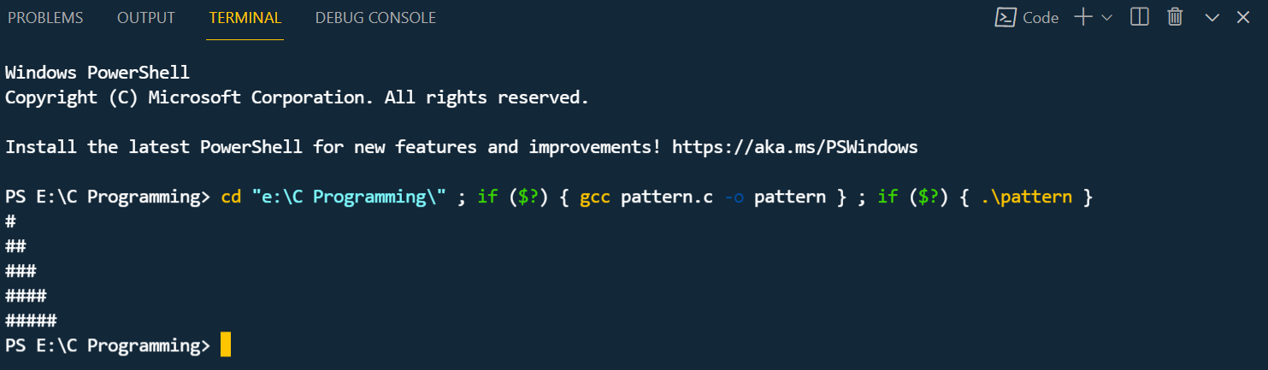

* Program:13

**INPUT:**

*//PROGRAM FOR NUM IS + , - OR 0  1904*

#include<stdio.h>

#include<conio.h>

void main()

{

int number;

printf("Enter the number-----");

scanf("%d",&number);

if(number>0)

{

printf("The number is positive");

}

else if(number<0)

{

printf("The number is negative");

}

else

{

printf("The number is zero");

}

getch();

}

**OUTPUT:**

1.

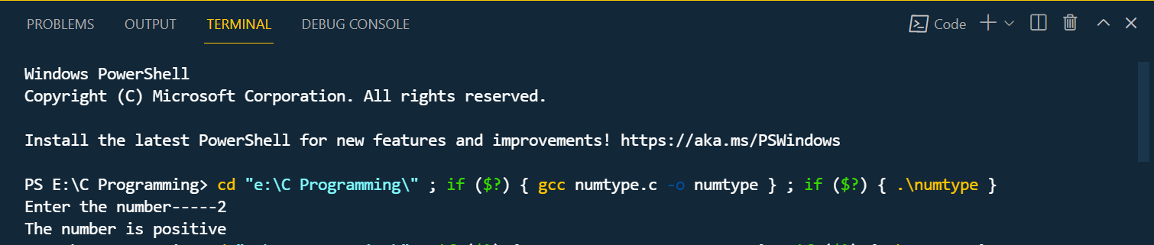

2.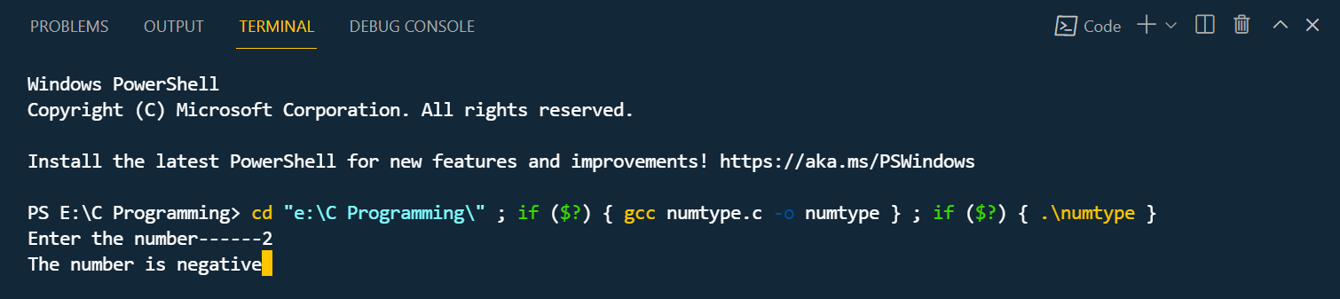

3.

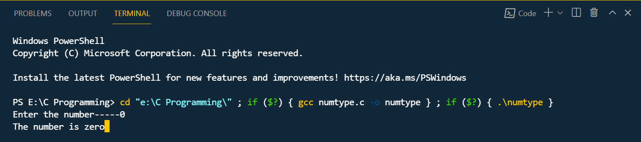

* Program:14

**INPUT:**

*//PROGRAM FOR DECLARING NO. IS PRIME OR NOT  1904*

#include<stdio.h>

#include<conio.h>

void main()

{

int n,i,flag=0;

printf("Enter a positive integer---");

scanf("%d",&n);

for(i=2;i<=n/2;++i)

{

if(n%i==0)

{

flag=1;

break;

}

}

if(flag==0)

{

printf("%d""is a prime number",n);

}

else

{

printf("%d""is not a prime number",n);

}

getch();

}

**OUTPUT:**

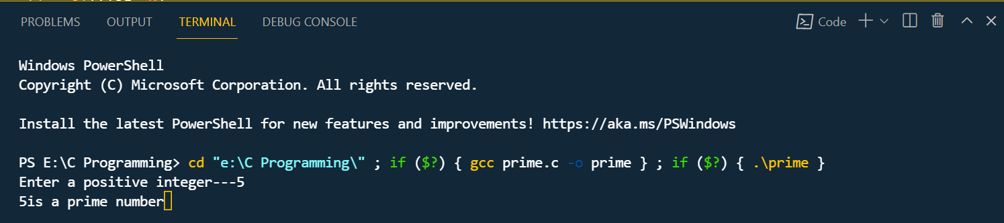

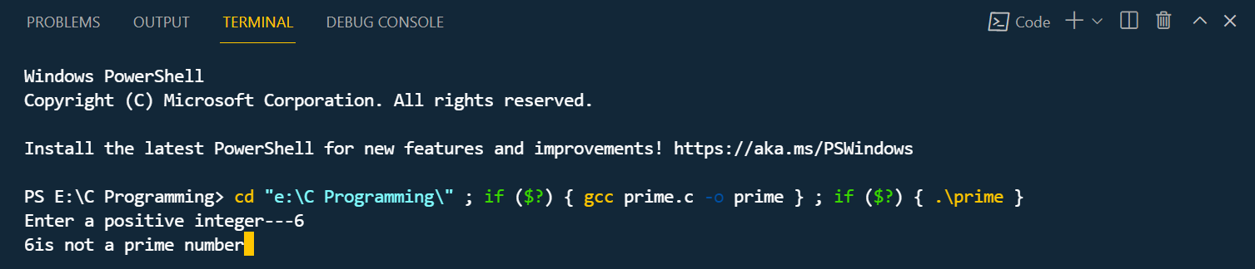

* Program:15

**INPUT:**

*//PROGRAM FOR LARGEST NO. 1904*

#include<stdio.h>

#include<conio.h>

void main()

{

double n1, n2, n3;

printf("Enter three numbers:");

scanf("%lf %lf %lf",&n1, &n2, &n3);

if( n1>=n2 && n1>=n3)

printf("%.2lf is the largest number.",n1);

else if (n2>=n1 && n2>=n3)

printf("%.2lf is the largest number.",n2);

else

printf("%.2lf is the largest number.",n3);

getch( );

}

**OUTPUT:**

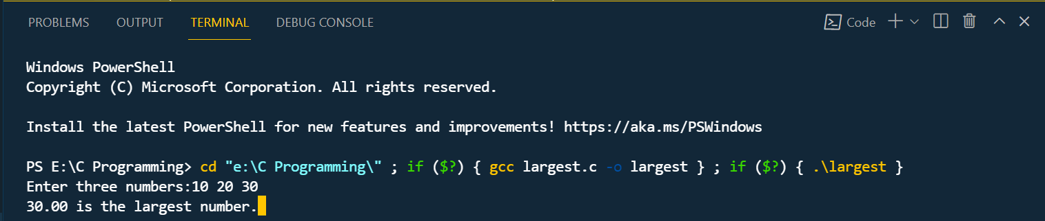

* Program:15

**INPUT:**

*//PROGRAM FOR FINDING SQUARES 1904*

#include<stdio.h>

#include<conio.h>

#include<math.h>

void main()

{

int n,t=0,r,q;

printf("Enter the number to be tested:");

scanf("%d",&n);

q=n;

do

{

r=q%10;

t=t+pow(r,2);

q=q/10;

}

while(q%10!=0);

printf("%d",t);

getch();

}

**OUTPUT:**

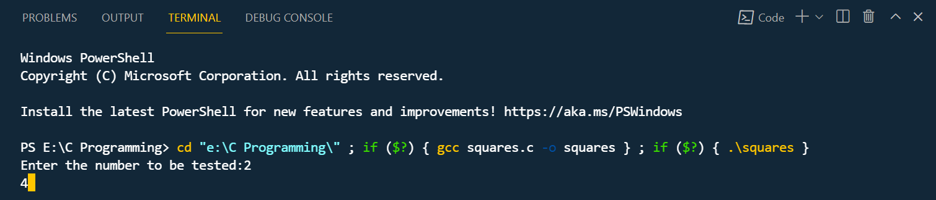

* Program:15

**INPUT:**

*//PROGRAM FOR REVERSE 1904*

#include<stdio.h>

#include<conio.h>

void main()

{

int n, reverse = 0;

printf("Enter a number to reverse:\n");

scanf("%d",&n);

while (n != 0)

{

reverse = reverse * 10;

reverse = reverse + n%10;

n = n/10;

}

printf("Reverse of entered number is = %d\n", reverse);

getch();

}

**OUTPUT:**

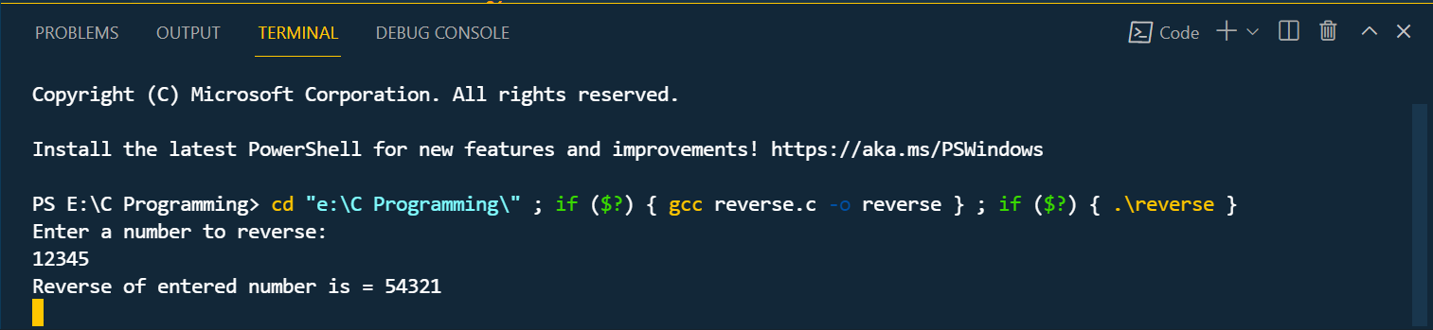

* Program:16

**INPUT:**

*//PROGRAM FOR VOLUME OF CUBE & CYLINDER  1904*

*#*include<stdio.h>

int main()

{

    float cube,hieght,rad,voc,pi=3.14;

    printf("enter the volume of cube");

    scanf("%f",&cube);

    printf("the volume of cube is : %f",cube*cube*cube);

printf("enter the hieght and rad for the volume of cylinder");

scanf("%f%f",&hieght,&rad);

voc=pi*hieght*rad*rad;

printf("The volume of cylinder is :%f%f",voc);

}

**OUTPUT:**

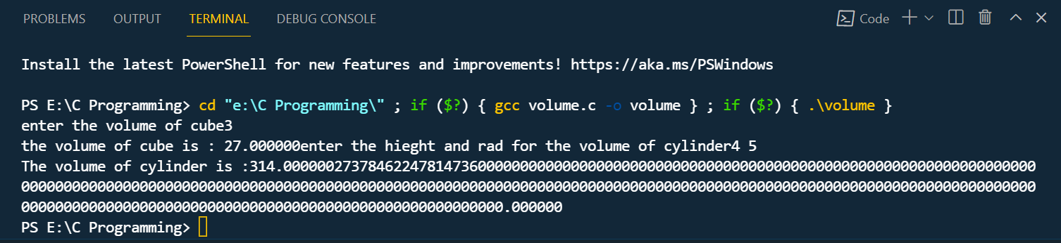

* Program:17

**INPUT:**

*//PROGRAM FOR LARGE ELEMENT IN ARRAY  1904*

#include<stdio.h>

#include<conio.h>

int main()

{

    int largest,size,array[10],i;

    printf("Enter your elements to store in array\n");

    scanf("%d",&size);

    printf("Now ready to enter %d numbers in array \n",size);

    for(i=0;i<size;i++)

    scanf("%d",&array[i]);

    largest=array[0];

    for(i=1;i<size;i++)

    {

        if(largest<array[i])

        largest=array[i];

    }

    printf("THE LARGEST ELEMENT IN ARRAY IS: %d\n,largest");

    return 0;

}

**OUTPUT:**

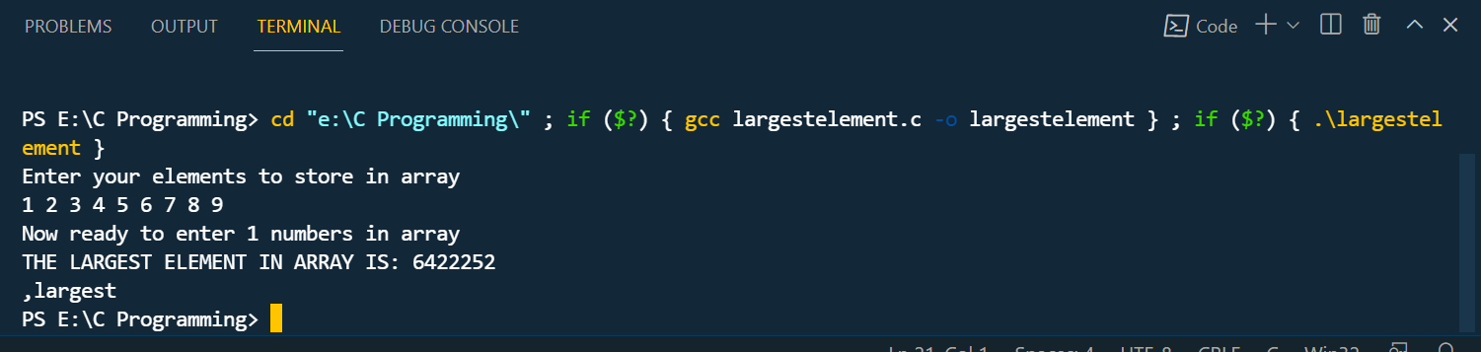

* Program:18

**INPUT:**

*//PROGRAM FOR FUNCTION  1904*

#include<stdio.h>

int main()

{

int i, a=20;

int arr[5]={10,20,30,40,50};

a=function(a, &arr[0]);

printf("Enter the value of a is %d\n", a);

for (i = 0; i < 5; i++)

{

printf("value of arr[%d] is %d\n", i, arr[i]);

}

return 0;

}

int function(int a, int* arr)

{

int i;

a=a+20;

arr[0]=arr[0] + 50;

arr[1]=arr[1] + 50;

arr[2]=arr[2] + 50;

arr[3]=arr[3] + 50;

arr[4]=arr[4] + 50;

return a;

}

**OUTPUT:**

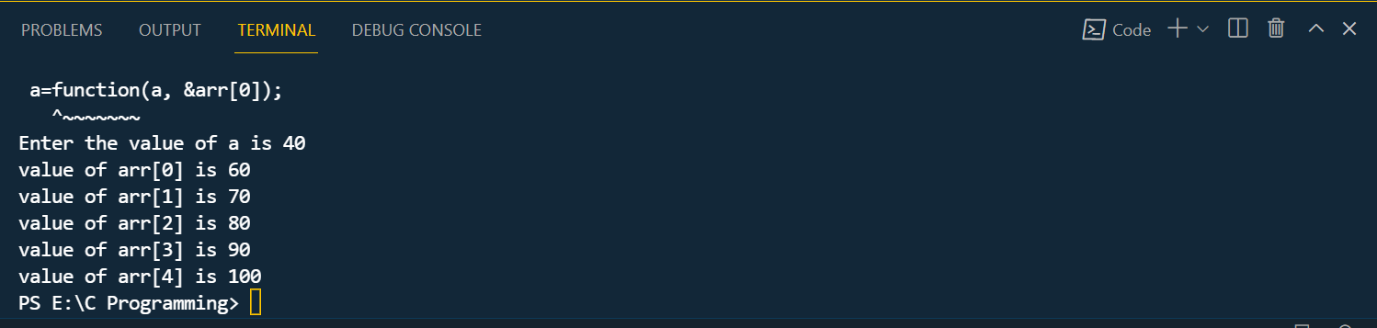

* Program:19

**INPUT:**

*//PROGRAM FOR ARRAY ELEMENT  1904*

#include<stdio.h>

int main()

{

int numArray[5];

int i,sum=0;

int*ptr;

printf("\nEnter 5 elements:");

for(i=0;i<5;i++)

scanf("%d",&numArray[i]);

ptr=numArray;

for(i=0;i<5;i++)

{

sum=sum + *ptr;

ptr++;

}

printf("The sum of array elements:%d",sum);

return 0;

}

**OUTPUT:**

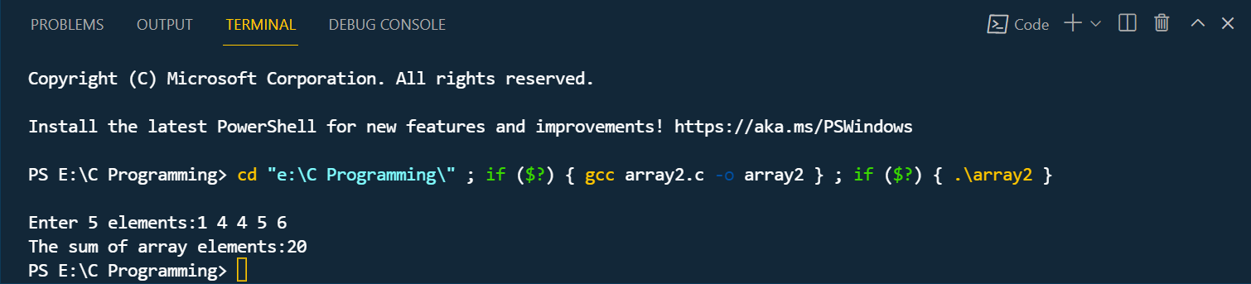

* Program:20

**INPUT:**

//PROGRAM FOR 'N' NO. STORED IN ASCENDING & DESCENDING ORDER 1904

#include <stdio.h>

int main()

{

int ar[100];

int size,i,j,temp;

printf("\n\nEnter size of array\n");

scanf("%d",&size);

printf("\n\nEnter element in array:\n");

for(i=0;i<size;i++)

{

scanf("%d",&ar[i]);

}

for(i=0;i<size;i++)

{

for(j=i+1;j<size;j++)

{

if(ar[j]<ar[i])

{

temp=ar[i];

ar[i]=ar[j];

ar[j]=temp;

}

**}**

**}**

printf("\nElements of array stored in ascending order\n\n");

for(i=0;i<size;i++)

{

printf("%d\t",ar[i]);

}

return 0;

}

**OUTPUT:**

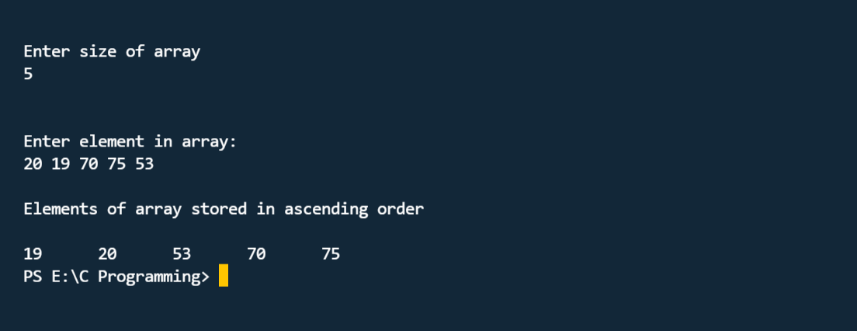

* Program:21

**INPUT:**

*//PROGRAM FOR A MATRIX  1904*

#include <stdio.h>

int main()

{

int m,n,c,d,first[4][4],second[4][4],sum[4][4];

printf("Enter the number of rows and columns of matrix\n");

scanf("%d%d",&m,&n);

printf("Enter the elements of first matrix\n");

for(c=0;c<m;c++)

for(d=0;d<n;d++)

scanf("%d",&first[c][d]);

printf("Enter the elements of second matrix\n");

for(c=0;c<m;c++)

for(d=0;d<n;d++)

scanf("%d",&second[c][d]);

printf("Sum of entered matrices:-\n");

for(c=0;c<m;c++)

{

for(d=0;d<n;d++)

{

sum[c][d]=first[c][d]+second[c][d];

printf("%d\t",sum[c][d]);

}

printf("\n");

}

return 0;

**OUTPUT:**

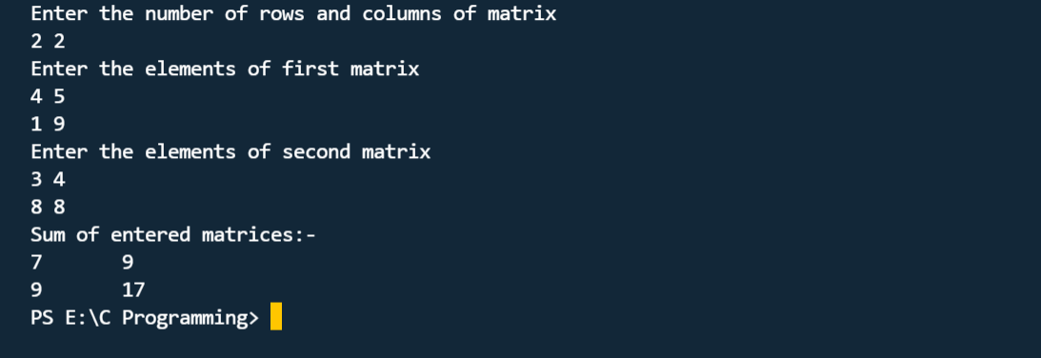

* Program:21

**INPUT:**

*//PROGRAM FOR MULTIPLICATION OF MATRIX  1904*

#include <stdio.h>

int main()

{

int a[5][5],b[5][5],c[5][5],i,j,k,sum=0,m,n,o,p;

printf("\nEnter the row and column of first matrix:");

scanf("%d %d",&m,&n);

printf("\nEnter the row and column of second matrix:");

scanf("%d %d",&o,&p);

if(n!=o)

{

printf("Matrix mutiplication is not possible");

printf("\nColumn of first matrix must be same as row of second matrix");

}

else

{

printf("\nEnter the First matrix->");

for(i=0;i<m;i++)

for(j=0;j<n;j++)

scanf("%d",&a[i][j]);

printf("\nEnter the Second matrix->");

for(i=0;i<o;i++)

for(j=0;j<p;j++)

scanf("%d",&b[i][j]);

printf("\nThe First matrix is\n");

for(i=0;i<m;i++)

{

printf("\n");

for(j=0;j<n;j++)

{

printf("%d\t",a[i][j]);

}

}

printf("\nThe Second matrix is\n");

for(i=0;i<o;i++)

{

printf("\n");

for(j=0;j<p;j++)

{

printf("%d\t",b[i][j]);

}

}

for(i=0;i<m;i++)

for(j=0;j<p;j++)

c[i][j]=0;

for(i=0;i<m;i++){ //row of first matrix

for(j=0;j<p;j++){ //column of second matrix

sum=0;

for(k=0;k<n;k++)

sum=sum+a[i][k]*b[k][j];

c[i][j]=sum;

}

}

}

printf("\nThe multiplication of two matrix is\n");

for(i=0;i<m;i++){

printf("\n");

for(j=0;j<p;j++){

printf("%d\t",c[i][j]);

}

}

return 0;

}

**OUTPUT:**

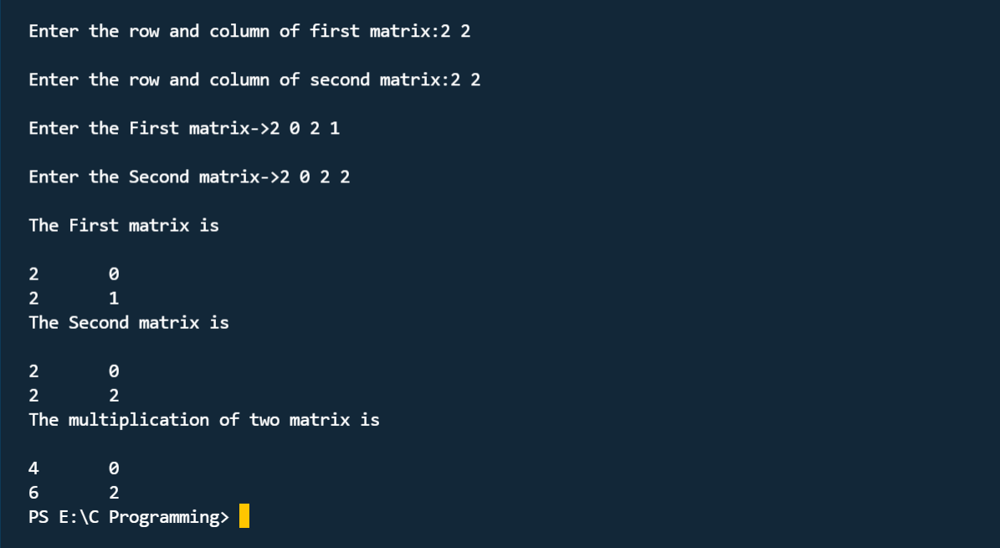

* Program:22

**INPUT:**

*//PROGRAM FOR ADDING TWO INT  1904*

#include <stdio.h>

int main()

{

int first,second,*p,*q,sum;

printf("Enter two integers to add\n");

scanf("%d%d",&first,&second);

p=&first;

q=&second;

sum=*p +*q;

printf("Sum of entered numbers = %d\n",sum);

return 0;

}

**OUTPUT:**

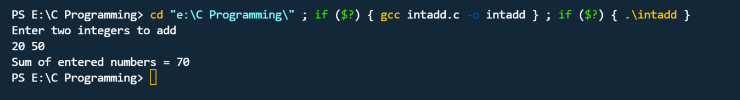

* Program:23

**INPUT:**

//PROGRAM FOR ADD & SUB OF TWO NOS. 1904

#include<stdio.h>

int main()

{

int num1,num2,sub,add,*p1,*p2;

printf("Enter first number: ");

scanf("%d",&num1);

printf("Enter second number: ");

scanf("%d",&num2);

p1=&num1;

p2=&num2;

add=*p1+*p2;

printf("\n\nAddition of%d and %d is %d",*p1,*p2,add);

sub=*p1-*p2;

printf("\n\nSubtraction of %d and %d is %d",*p1,*p2,sub);

return 0;

}

**OUTPUT:**

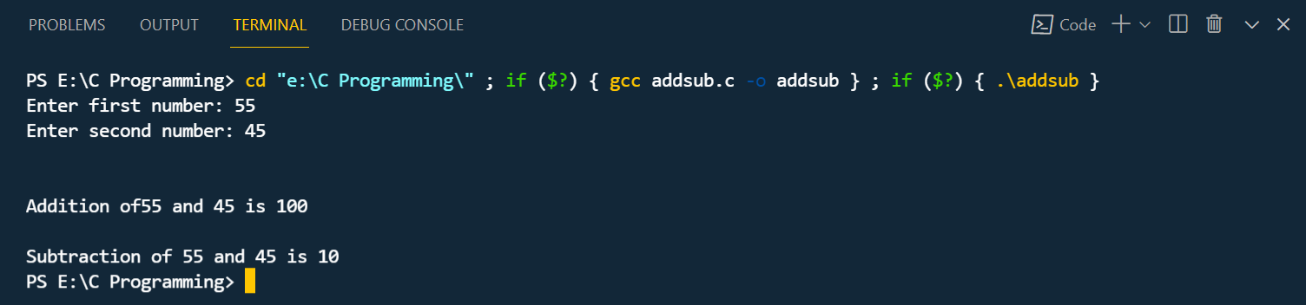

* Program:24

**INPUT:**

//PROGRAM FOR SWAPPING 1904

#include<stdio.h>

void swap(int*a,int*b);

int main()

{

int m=45, n=33;

printf("values before swap m=%d and n=%d\n",m,n);

swap(&m,&n);

}

void swap(int *a,int *b)

{

int tmp;

tmp= *a;

*a = *b;

*b = tmp;

printf("\n values after swap a = %d and b = %d",*a, *b);

}

**OUTPUT:**

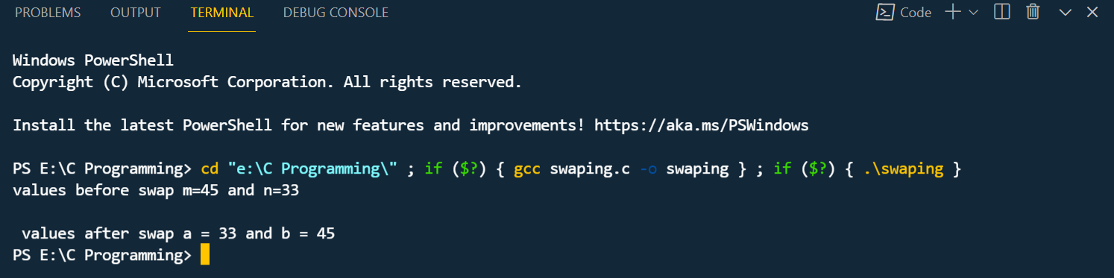

* Program:25

**INPUT:**

*//PROGRAM FOR STRING  1904*

#include<stdio.h>

#include<conio.h>

union *sample*

{

    int num;

    char str[10];

    float real;

};

int main()

{

    union *sample* s;

    printf("enter the number");

    scanf("%d",&s.num);

    printf("\n number : %d",s.num);

    printf("\nenter a string");

    scanf("%s",s.str);

    printf("\n string :%s",s.str);

    printf("\n enter a real value:");

    scanf("\n %f",&s.real);

    printf("\n real number : %f ,s.real");

    return 0;

}

**OUTPUT:**

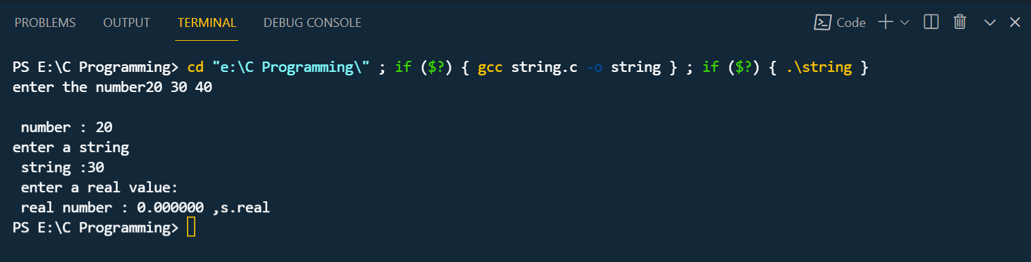

* Program:26

**INPUT:**

*//PROGRAM FOR FINDING DIFFERENCE  1904*

#include<stdio.h>

#include<stdio.h>

int main()

{

    int num1,num2,sub,add,*p1,*p2;

    printf("enter the first number:");

    scanf("%d",&num1);

    printf("enter the second number:");

    scanf("%d",&num2);

    p1=&num1;

    p2=&num2;

    add=*p1+*p2;

    printf("\naddition of %d and %d is %d",*p1,*p2,add);

    sub=*p1-*p2;

    printf("\ndifference of %d and %d is %d",*p1,*p2,sub);

    return 0;

}

**OUTPUT:**

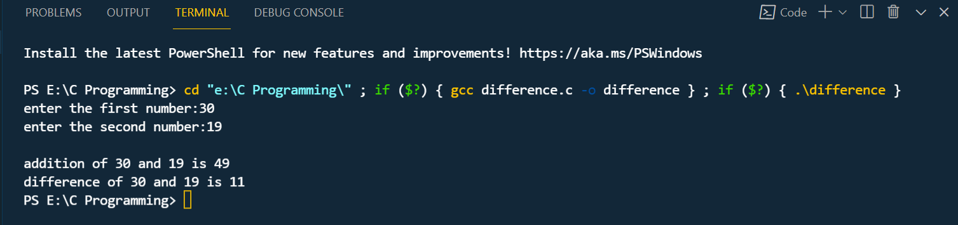

* Program:27

**INPUT:**

*//PROGRAM FOR STRUCTURE  1904*

#include<stdio.h>

#include<conio.h>

int main()

{

    struct *employee*

    {

        int empno;

        char name[30];

        float salary;

        char designation[30];

    };

    struct *employee* emp1 = {100,"sanjay",50000,"manager"};

    printf("\n employee number: %d",emp1.empno);

    printf("\n employee name; %s",emp1.name);

    printf("\n employee salary : %f",emp1.salary);

    printf("\n employee designation: %s",emp1.designation);

    return 0;

}

**OUTPUT:**

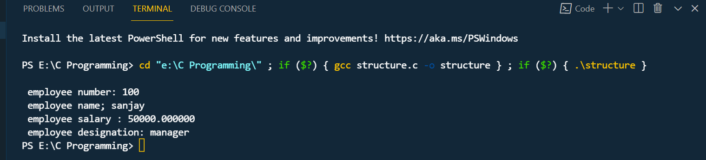

* Program:28

**INPUT:**

*//PROGRAM FOR @ PATTERN  1904*

#include <stdio.h>

#include <conio.h>

int main()

{

    int i,j;

    for(i=1;i<=5;i++)

    {

    for(j=1;j<=i;j++)

    {

    printf("@");

    }

    printf("\n");

    }

    return 0;

}

**OUTPUT:**

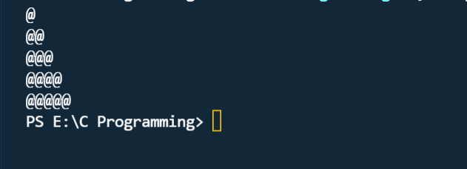

* Program:29

**INPUT:**

*//PROGRAM FOR $ PATTERN  1904*

#include <stdio.h>

#include <conio.h>

int main()

{

    int i,j;

    for(i=1;i<=5;i++)

    {

    for(j=1;j<=i;j++)

    {

    printf("$");

    }

    printf("\n");

    }

    return 0;

}

**OUTPUT:**

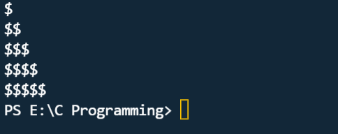

* Program:30

**INPUT:**

*//PROGRAM FOR CHAR INT FLOAT DOUBLE  1904*

#include<stdio.h>

int main()

{

    char c='A';

    int n=23;

    float f=34.45;

    double d=113412.343;

    printf("\n char value = %c",c);

    printf("\n int value = %d",n);

    printf("\n float value = %f",f);

    printf("\n double value = %if",d);

    return 0;

}

**OUTPUT:**

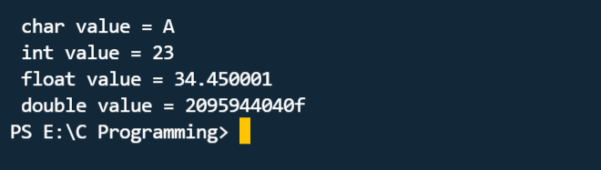

* Program:31

**INPUT:**

*//PROGRAM FOR COUNT  1904*

#include<stdio.h>

int main()

{

    int count=1;

    while (count<=10)

    {

        printf("%d",count);

        count ++;

    }

    printf("Hello you are out of the LOOP now");

    return 0;

}

**OUTPUT:**

